ĐỀ 2 – PMG201- FALL 23 - Chữa đề buổi1

1.

FPT University Convocation Day - level 1

1.1 Initiating level 2

1.1.1 Confirm project requirements / scope - level 3

1.1.2 Create project charter and get approval - level 3

1.1.3 Identify Stakeholder ( internal stakeholder >< external stakeholder)

1.1.4 Hold a kick-off meeting

1.2 Planning - level 2

1.2.1 Develop project management plan (Budget , resource, risk , schedule, scope management plan, procurement management plan , quality management plan ) level 3

1.2.2 Create detailed planning of work items

1.2.3 Define program execution sequence/ Create event schedule

1.2.4 Decide the mainstream style

1.2.6 Solidifying the list of guest

1.2.7 Create a list of cultural performances of clubs

1.2.8 Create stage sketches , logistics ..

1.3 Executing

1.3.1. Pre-Event Activities

1.3.1.1. Student Registration

1.3.1.2 Sent invitation to speakers /guests

1.3.1.3. Communication before the event (Guest Speaker Coordination )

1.3.1.4 Confirm the commitment of cultural performance

1.3.1.5. Material Preparation

1.3.1.6 Setting up the stage

1.3.1.7 Rehearsal

1.3.2. Running Event

* Run the program

1.3.2.1. Opening Ceremony

1.3.2.2. Student Procession

1.3.2.3. Degree Distribution

1.3.2.4. Awards Presentation

1.3.2.5 Monitor the program sequence

1.3.3. Post-Event Activities

1.3.3.1. Clean-up

1.3.3.3. Evaluate Event Success

1.4 Closing

1.4.1 Payment to suppliers (Complete Financial Closure)

1.4.2 Thank you letter to guests/partners

1.4.3. Document Lessons Learned

1.4.4. Send Appreciation Notes

1.4.5.Archive Event Data

WBS dạng bài launch 1 sản phẩm mới (sữa , noodle< vv) – sẽ đính kèm trong bài chữa buổi 2

Request 2

**Risk Title: Technical Issues during the Event**

**High , medium , low , extreme**

Risk Impact: High

Risk Probability: Moderate

Risk Exposure: The risk exposure is high during the running event phase when technical issues may disrupt the schedule of the convocation day , affecting live streaming, audio systems, or other event-related technologies.

Risk Mitigation Actions:

* Conduct thorough technical rehearsals in the actual event space to identify and resolve potential issues.
* Have a dedicated technical support team on standby during the event to address any immediate problems.
* Use reliable and tested equipment and software to minimize the likelihood of technical failures.

Risk Contingency Actions: Contingency plan *(unforeseen risk )

* Establish a backup plan for critical technical components, such as a secondary internet connection or backup audio systems.

**Risk Title: Guest/ Speaker Unavailability**

Risk Impact: Moderate

Risk Probability: Low

Risk Exposure: The risk exposure is during the planning phase and executing phase when confirming guest speakers. If a scheduled speaker becomes unavailable, it could impact the overall event program and experience for attendees.

Risk Mitigation Actions:

Confirm speaker availability well in advance

Maintain clear communication with potential speakers and have a contingency plan in place in case of unforeseen circumstances.

Risk Contingency Actions:

Develop a list of alternative speakers who are willing and available to step in if needed.

Establish a communication plan to inform attendees promptly and transparently about any changes to the speaker lineup, ensuring minimal disruption to the event.

**Gợi ý thêm 1 vài Risk khác có thể apply vào dạng bài khác nhau**

| Risk | Possibility | Impact | Mitigation Plan | Contingency Plan |
| --- | --- | --- | --- | --- |
| Wrong budget estimate and cost overruns | MODERATE | EXTREME | Establish the scope before beginning work, pay a lot of attention to project planning and constantly track and measure the progress by EVM | cut down on the project scope |
| The project schedule is too tight; it’s hard to complete this project on time | HIGH | HIGH | Set The   priority for each of the  activity | negotiate with customer to reschedule |
| Project manager has poor management skill | MODERATE | MODERATE | Plan leadership training for manager | choose another one |
| A lack of cooperation negatively affects your member productivity | MODERATE | MODERATE | Encourage each team member in his task, and inspire them to greater efforts | Encourage each team member in his task, and inspire them to greater efforts |
|  |  |  |  |  |
|  |  |  |  |  |

Request 3

**project duration is the longest path duration**

**critical path method / critical chain method**

**ES early start + thời gian sớm nhất đê bắt đầu 1 cviec**

**EF early finish thời gian sớm nhất đê hoàn thành 1 cviec**

**LS late start thời gian muộn nhất để bắt đầu 1 cviec**

**LF late finish thời gian muộn nhất để kết thúc 1 cviec**

**forward pass**

**backward pass**

**TH1 : early start = 1 , 1 based planning project**

**EF = ES + duration – 1**

**ES của task sau = EF của task trước + 1**

Path 1 Start -> A -> F -> G -> E -> End = 0 + 1 + 2 + 7 + 1 + 0 = duration 11 weeks

Path 2 Start -> A -> F -> C -> End duration 5 weeks

Path 3 Start -> D -> F ->G -> E -> End duration 17 weeks -> 14 weeks

Path 4 Start -> D-> F -> C -> End duration 11 weeks

Path 5 Start -> D -> H -> B -> End duration 16 weeks

Project duration is 17 weeks

**TH2:**

**ES = 0 , 0 based planning**

**EF = ES + duration**

**ES task sau = EF task trước**

**Request 4 (cho thêm ) - Schedule Adjusting**

**With project in request 3, After 5 weeks, your sponsor ask you to speed up and finish the project 3 weeks sooner. Please define 2 solutions with relevant explanation to achive that (how it would help and difficulties, impacts to the project). You can provide your assumption for your explanation if needed**

Answer:

 If you want to shorten the project time by 3 weeks which means the new duration of the project is 14 weeks , none path can exceed this number. First of all, when calculate the activity to decrease the duration , you have to consider firstly all the task in critical path- the path that has longest duration , but now 5 weeks have passed, (now you’re in task A and D ), so we have a way to shorten the time in task F, G, E . The appropriate choice is left with task G because a task with a duration of 7 weeks should be prioritized to shorten the time. So we will have a plan to shorten the task G by 3 weeks to only 4 weeks .

But after the critical path had been reduced to 14 weeks, Path 5 still exceeding this new duration (path 5’s duration is 16 weeks) . Obviously, we have to reduce path 5 by 2 weeks . Task B should be prioritized to reduce 2 weeks as it has the longer duration.

Briefly , in order to reduce the project duration by 3 weeks, we have to shorten task G by 3 weeks and task B by 2 weeks.

The shortening method is as follow:

Crashing method

·         Solution 1:   Add people to join project to complete task H earlier than 5 weeks

·          Solution 2   Force team to work overtime on task H to complete it earlier than 5 weeks

·         //Solution 3 Reward team if they can complete task H earlier than 5 weeks //

* Crashing will increase cost.

**Request 4 EVM**

PV của thời điểm hiện tại bằng BAC / DAC x thời gian hiện tại

CV= EV - AC

SV = EV - PV

CPI = EV/AC

SPI = EV/PV

EAC = BAC/CPI

EDAC = DAC/SPI

ETC = EAC - AC

* **EAC = AC + ETC:** This formula is the most generic and is often used when BAC is estimated from inaccurate or erroneous data. In this case, the EAC represents the sum of Actual Cost (AC) and Estimate to Completion (ETC).
* **EAC = BAC / CPI:** This is the most recommended calculation when the project is in progress without interference. To check the EAC, divide the BAC by the Cost Performance Index (CPI).
* **EAC = AC + （BAC – EV ）/ CPI x SPI:** This is the formula used when schedule delays and expenses increase. In this case, it’s necessary to add the Schedule Performance Index (SPI) and the Earned Value (EV) to the equation.
* **EAC = AC + (BAC – EV)** This formula is used when unforeseen events are overcome, and it’s believed that new interference will not occur until the end of the project.

From the project metric , we have :

SV = 50000000 (VND)

CV = -100000000 (VND)

AC = 300000000 (VND)

BAC = 450000000 (VND)

DAC = 24 (month)

Apply the EVM

CV= EV - AC

=> EV (Earn Value ) = CV + AC = - 100000000 + 300000000 = 200000000

=> CPI ( cost performance index)= EV/AC = 200000000/300000000 = 0.67 (<1)

So this project is currently over budget

**=> PV(Plan value) = 450/24 x 12 = 225000000**

=> SPI = EV/PV = 200000000/225000000 = 0.89

So this project is currently below the schedule

EAC (estimate at completion) when both CPI and SPI affect the project is

EAC (Estimate at completion) = AC + (BAC – EV) / (CPI x SPI) = 300000000 + (450000000 - 200000000)/0.67x0.89 = 716 666 666 (VND)

ETC ( Estimate to complete) = EAC - AC =716666666-300000000= 416000000 (VND)

**Stakeholder power / interest grid**

Planning / create project management plan / stakeholder management plan

Internal stakeholder / 　　External stakeholder

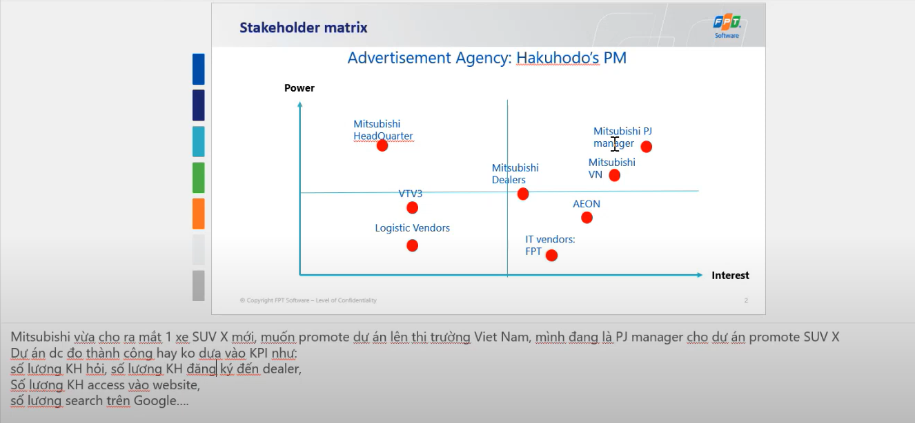

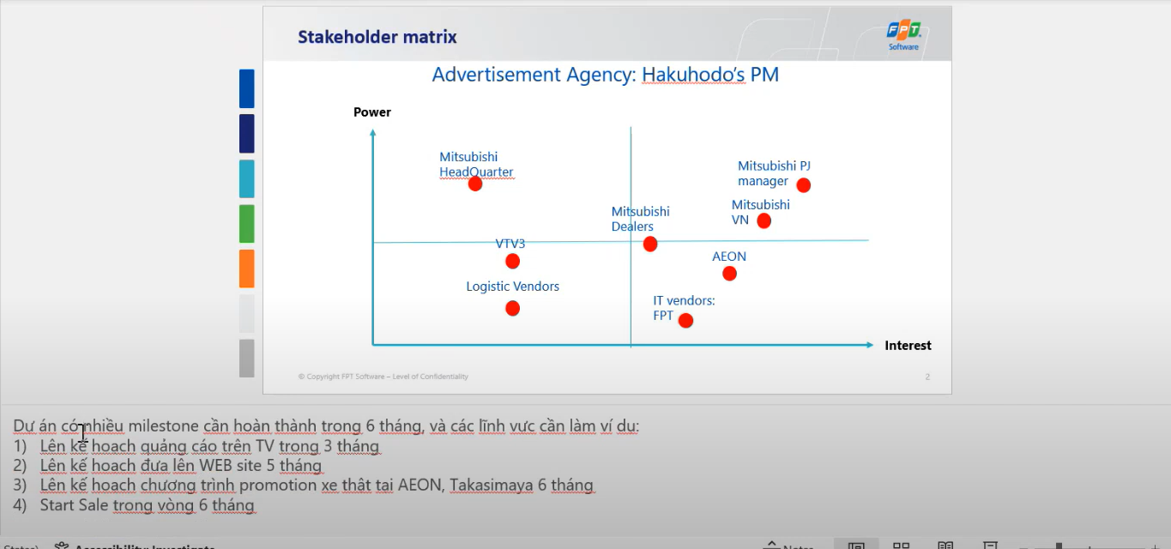

**High power - High interest: these are the stakeholders are decision makers and have the biggest impact on the project success and hence we must closely manage their expectations.**

**High power - Low Interest: these are the stakeholder needed to be kept in loop, these stakeholders need to be kept satisfied even though they aren’t interested because they yield power. These type of stakeholders should be dealt with cautiously as well since they may use their power in a not desired way in the project if they become unsatisfied.**

**Low power – High interest: keep these people adequately informed, and talk to them to ensure that no major issues are arising. These people can often be very helpful with the detail of your project.**

**Low power - low interest: monitor these people, but do not bore them with excessive communication**

| High power – low interest  ABC company headquarter | High power – high interest  PM , ABC VN company |
| --- | --- |
| Low power – low interest  VTV 3  Logistic vendor | Low power – high interest  AEON  IT vendors |

**High power- high interest: closely manage their expectations.**

**High power- low interest: keep satisfied**

**Low power - high interest: keep informed**

**Low power - low interest: monitor these people, but do not bore them with excessive communication**